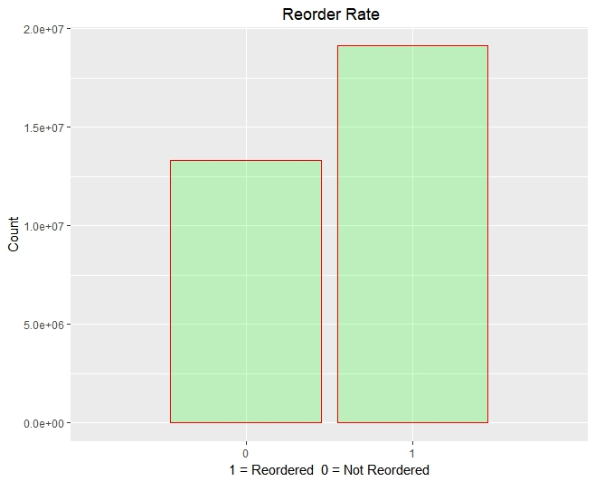

**This shows that there are a large number of products reordered which is a good thing to investigate frequently ordered products.**

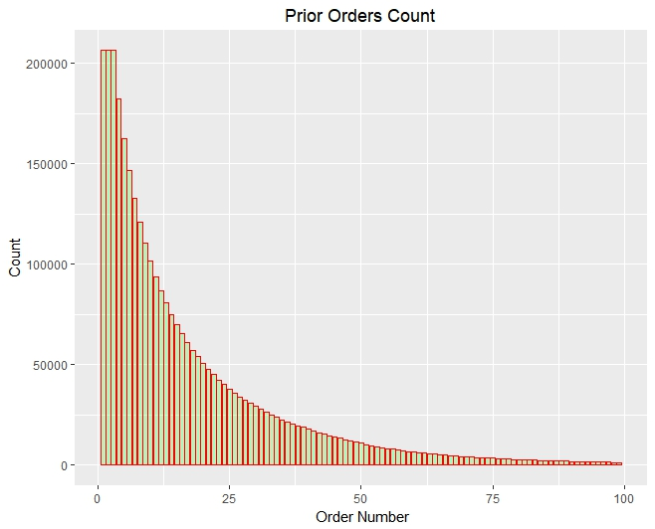

**The next plot shows the number of items purchased in each of the orders placed by the customers. It can be noticed that in majority of the orders a minimum of five items are purchased per order by a customer**

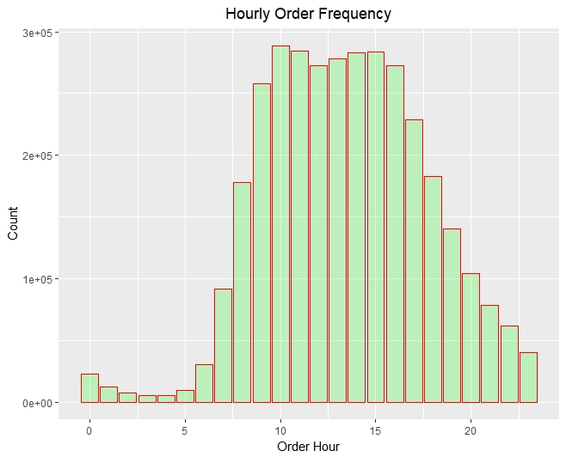

**The below visualization displays the hours for which the maximum sale is recorded. The visualization depicts that the maximum sale occurs between 8:00 and 18:00 hours of the day**

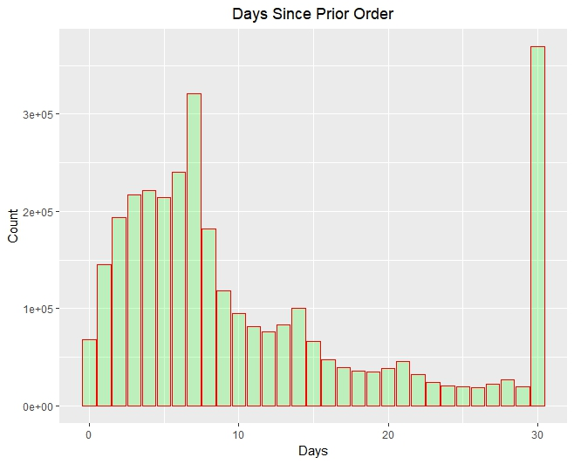

**The below visualization presents the reorder frequency of the customers. From the plot, we can see that in majority of the cases the reorder occurs exactly after a week span**

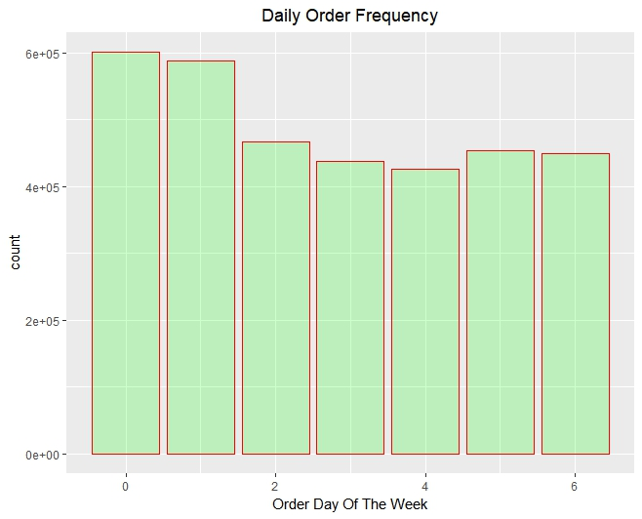

**The below visualization displays the order distribution across the days of the week. From the visualization, we can notice that the maximum sales occur on the weekend**

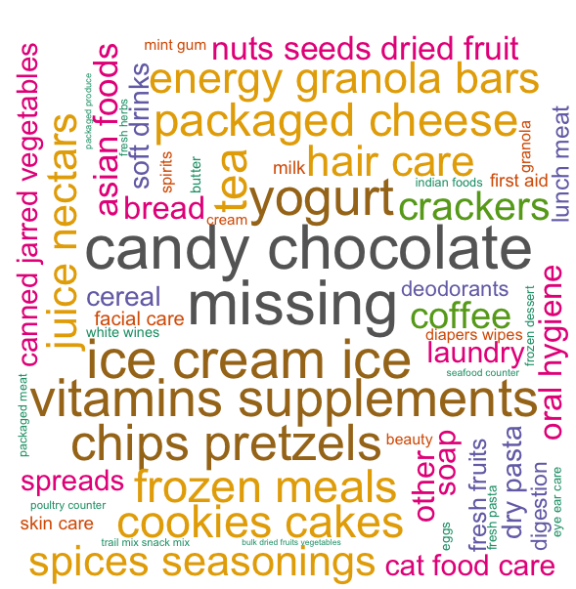

**Ranking aisles based on number of unique products**

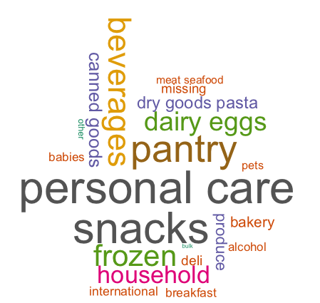

**The below visualization depicts the most popular aisle and department based on the products present in maximum orders. The plot is obtained using basic text mining functions**

**Points to explore :-**

* **From this we can understand trends in the data and frequency of the items, what we could explore further is conducting a Market Basket analysis to find out frequently purchased item sets and derive some insights based on that.**